**Other CSS Selectors**

1. Universal Selector

It works a s a wild card character selecting all elements on a page.

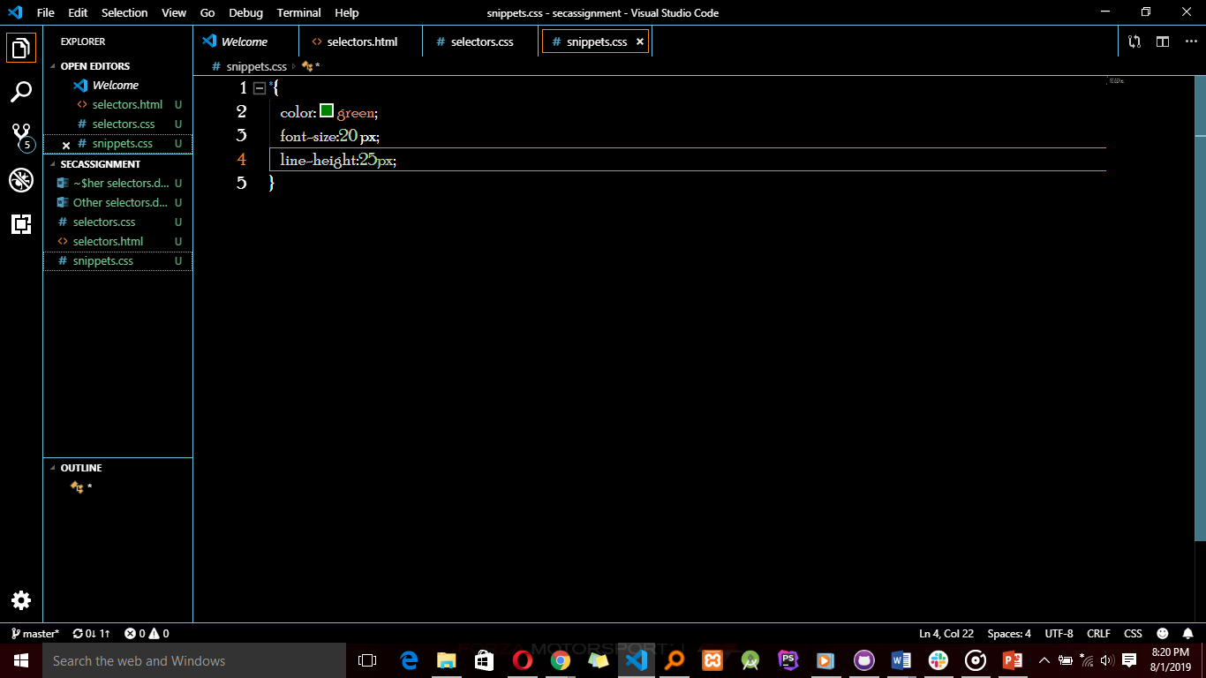

The three lines apply to all elements on the HTML page.

1. General sibling combinatory

This selector matches elements based on sibling relationships asin selected elements are beside each other in the Html.

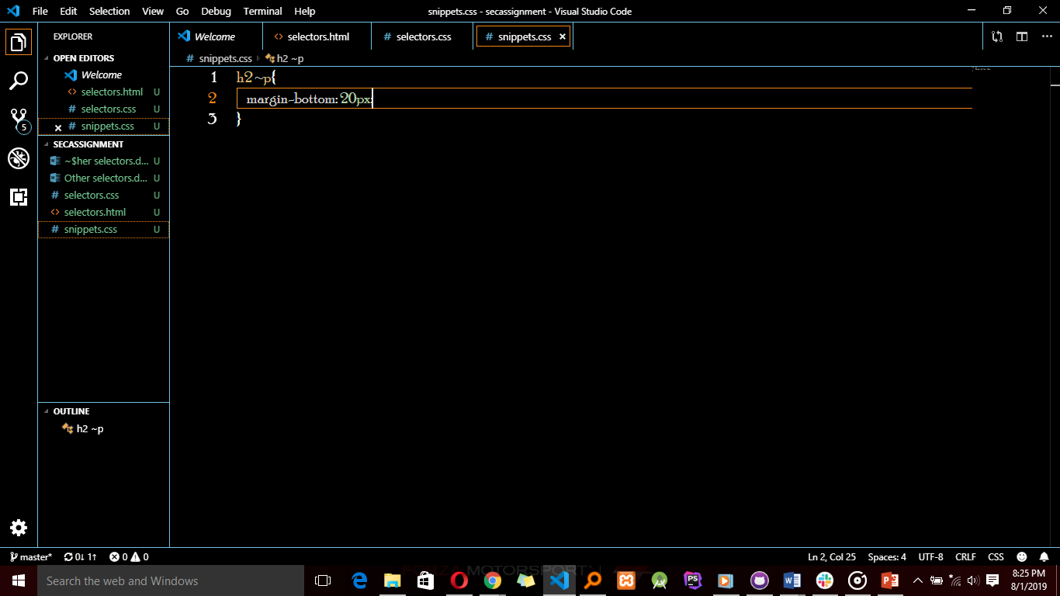

This selector is declared using the tilde (~) character.

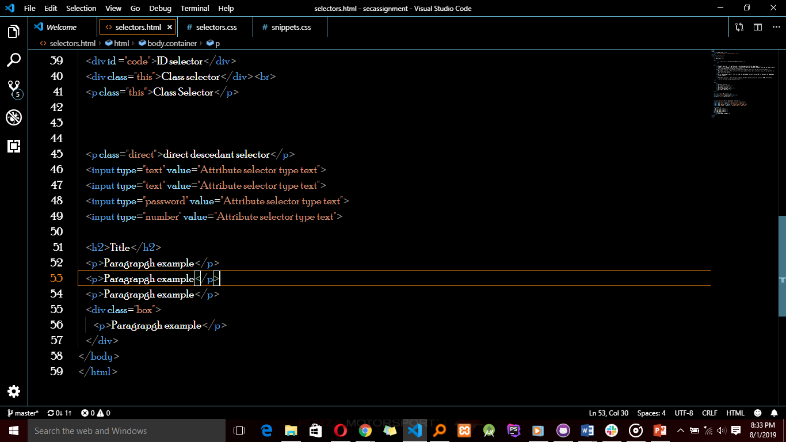

So all paragraphs who are siblings with h2 will be styled with the margin-bottom code in this case, the first three paragraphs and not the last paragraph because it is in a div.

It also applies to the elements between the <h2> and <p>

1. Adjacent sibling combinator.

It uses the ‘+’ symbol and is similar to the general sibling selector but the targeted element must be an immediate sibling and not any sibling.

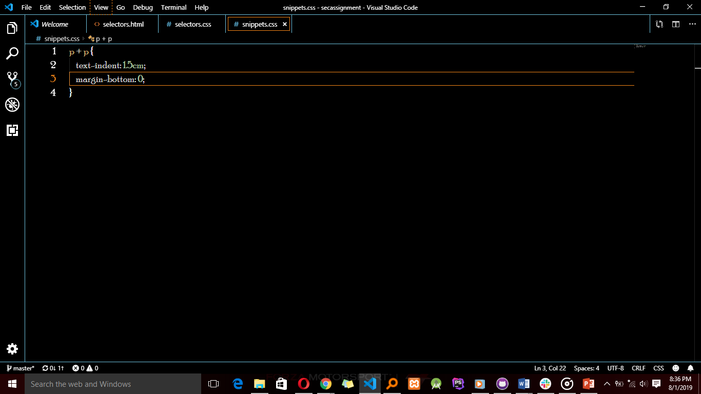

If we apply the above lines to the HTML below,

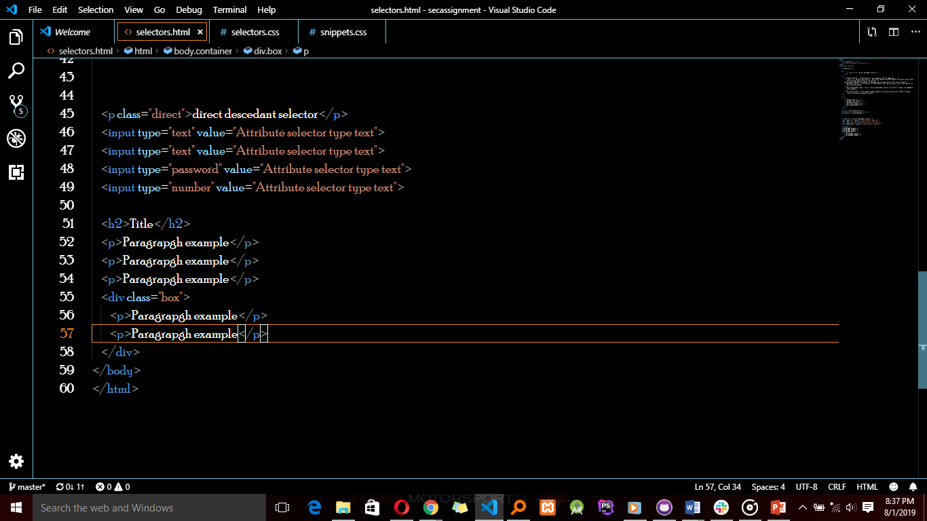

The styles will only affect the second, third and fifth paragraphs.

1. Pseudo-class

It uses a colon character to identify a pseudo-state that an element might be in eg the state of being hovered.

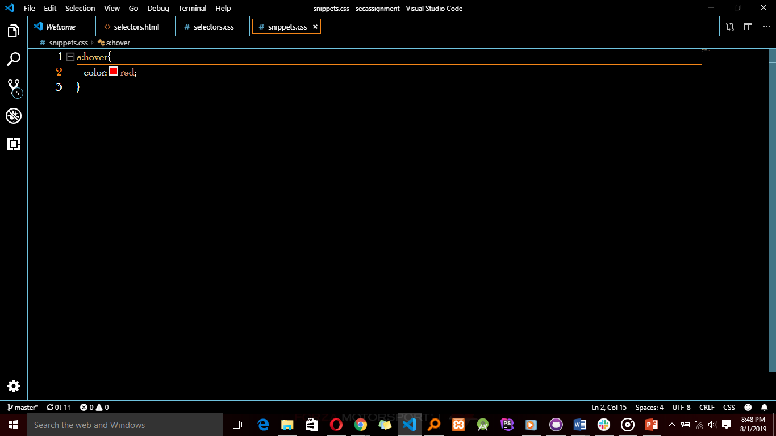

So now it means that this pseudo-class has been attached too all anchor elements. So when the user hovers over them, the color property will be activated to red.

Therefore, I concluded that these selectors don’t just select elements but elements in a particular state.

1. Pseudo-element

We are using an example with one kind of pseudo-element ie the ‘before’. This inserts an imaginary element into the page, inside the targeted element, before its contents.

